

Tech Saksham

3

Case Study Report

Data Analytics with Power-BI

# “360-DEGREEBUSINESSANALYSIS OF ONLINE DELIVERY APPS”

## “CAUSSANEL COLLEGE OF ARTS&SCIENCE”

|  |  |
| --- | --- |
| **NMID** | **NAME** |
| FB5B898EAB1179887CE4E1BAB72AC042 | VISHNU.M |

**Trainer Namc**: R UMAMAHESWARI

**Master Trainer**: R UMAMAHESWARI

# ABSTRACT

In the tech world, Online food ordering system is mainly designed primarily function for use in the food delivery industry. This system will allow hotels and restaurants to increase online food ordering such type of business. The customers can be selected food menu items just few minutes. In the modern food world allows to quickly and easily delivery on customer place. Restaurant workers then use these orders through an easy to delivery on customer place easy find out navigate graphical interface for the quality running.

**INDEX**

|  |  |  |
| --- | --- | --- |
| **Sr.No.** | **Table of Contents** | **Page No.** |
| 1 | Chapter1:Introduction | 4 |
| 2 | Chapter2:Servicesand Tools Required | 6 |
| 3 | Chapter3:Project Architecture | 7 |
| 4 | Chapter4:Modeling and Result | 9 |
| 5 | Conclusion | 15 |
| 6 | Future Scope | 16 |
| 7 | References | 17 |
| 8 | Links | 18 |

### CHAPTER 1 INTRODUCTION

#### Problem Statement:

Different food delivery applications often provide different offers or discounts. Users are also not satisfied with their delivery time and random cancellations.

The current food delivery applications provide different discounts on the same item but in different platform.It is also seen that delivery time of anitem is not same in all the applications. Adding all the discounts and estimated delivery time of different food joints under a single interface will be economical and less time consuming**.**

#### Proposed Solution:

The proposed solution is to develop a Power-BI dashboard that can analyze andvisualize Business Analysis of food delivery App.It’s time to create solutions for the problem.To underst and their situation,I have to step in to their shoes.Here are the ideas that I have thought of Bringing discounts and offers of different applications underasing leinter face.Comparing the delivery time of different apps together. Users will get an idea of the timings and they can choose accordingly. No cancellation guarantee should be provided before placing an order maybe in form of anicon which can be accessed by the restaurant manager and connected to their website.

##### Feature:

* **Real-Time Order Tracking**: The dashboard will provide real-time order tracking of Hungry customers want their meals delivered fast.
* **Customer Segmentation**: It will segment customers based on perceptions about service quality, bargain hunter, impatient, interested in new innovations, etc.
* **Trend Analysis**: The dashboard will identify and display trends in customer behavior.
* **Predictive Analysis**: It will use historical data to predict future customer behavior.

##### Advantages:

* **Time saving**: To save consumers’ time by removing the need to goto restaurants in person or stand in queue for take away orders.
* **Promotions and Discounts**: To provide exclusive offers, discounts, and loyalty awards to draw in new clients and keep existing ones coming back.
* **Revenue Generation**: Bringmoney through delivery fees,commissions from affiliated eateries, and prospective advertising opportunities.

##### Scope

Food delivery apps are third-party services that connect restaurants with customers,conveniencestores,and more. In such atechnological era,peoplefind it difficult to visit restaurants. Most often, they are unable to manage time for picking up their order. Therefore, most of them like to use the food delivery app. They allow customers to order food from restaurants, compare prices, and see estimated delivery times. Food delivery apps also help restaurants improve customer satisfaction by reducing wait times and helping employees connect with customers.

### CHAPTER2

**SERVICES AND TOOLS REQUIRED**

#### Services Used:

There are numerous benefits of online food delivery service,such as

* + - Audiences can make orders for many where else.
    - The online delivery service saves time from the customer side.
    - Restaurants can collect better customer data.
    - Most restaurants offer online **food delivery 24 hours**. That's why customers can make **late night food delivery orders**.

#### Tools and Software used Tools:

* + - **Power BI**: The main tool for this project is Power BI, which will be used to create interactive dashboards for real-time data visualization.
    - **Power Query**: This is a data connection technology that enables you to discover, connect, combine, and refine data across a wide variety of sources.

#### Software Requirements:

* + - **Power BI Desktop**: This is a Windows application that you can use to create reports and publish them to Power BI.
    - **Power BI Service**: This is an online Sales(Software as a Service) service that you use to publish reports,create new dashboards,and share insights.
    - **Power BI Mobile** : This is a mobile application that you can use to access your reports and dashboards on the go.

### CHAPTER 3 PROJECT ARCHITECTURE

#### Architecture

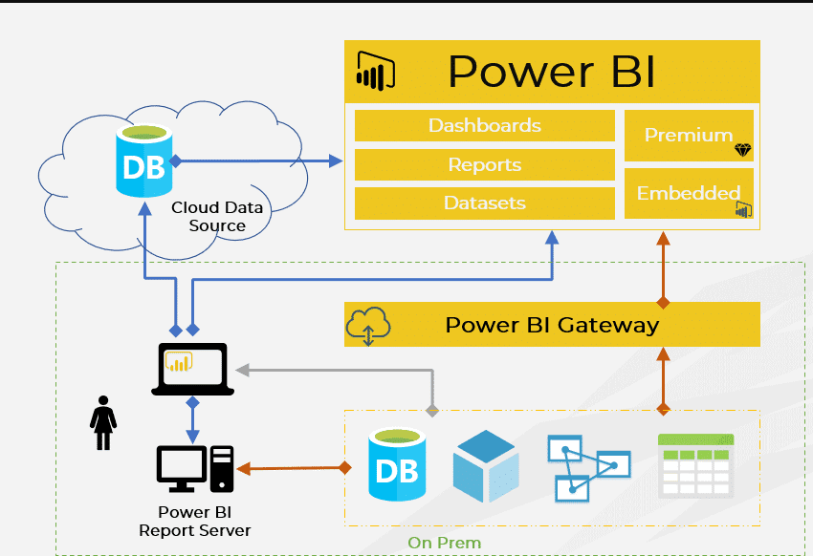

Here’s a high-level architecture for the project:

* + 1. **DataProcessing**:Fooddeliveryappscanusedatatohelpimprove customer satisfaction, build brand image, and increase sales.
    2. **Machine Learning**: Food delivery apps use machine learning to improve their algorithms, which can help users get a more personalized experience. For example, Zomato uses machine learning to automate menu digitization, create personalized restaurant listings, and predict food preparation times.
    3. **Data Visualization**: The processed data and the results from the predictive models are visualized in real-time using Power BI. Power BI allows you to create interactive dashboards that can provide valuable insights into the data.

##### 4.Data Access: The dashboards created in PowerBI can be accessed through Power BI Desktop,Power BI Service(online),and Power BI Mobile.

This architecture provides a comprehensive solution for real-time analysis of food delivery apps. However, it’s important to note that the specific architecture may vary depending on the food delivery connection, specific requirements, and budget. It’s also important to ensure that all tools and services comply with relevant data privacy and security regulations.

### CHAPTER 4 MODELING AND RESULT

**Manage relationship**

The “cuisines” file will be used as the main connector as it contains most key identifier (Restaurant ID, Fact table and Zomato global) which can be uses to relates the 4 data files together. The “country code” file is use to link the client profile geographically with “Zomato global”

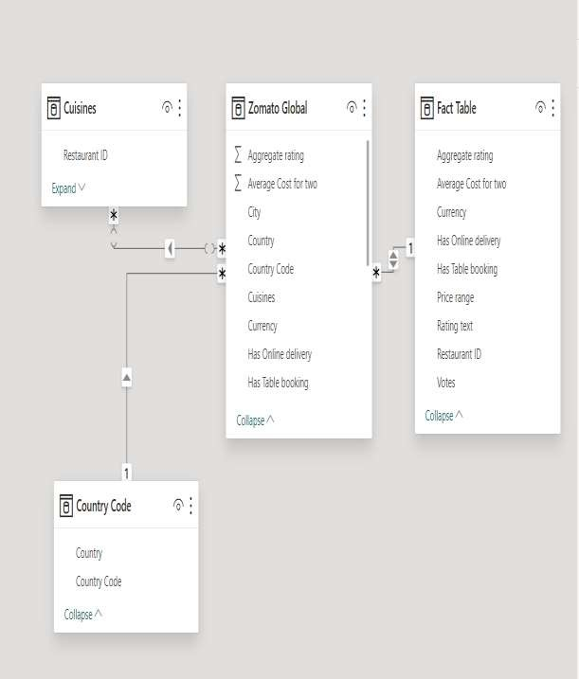

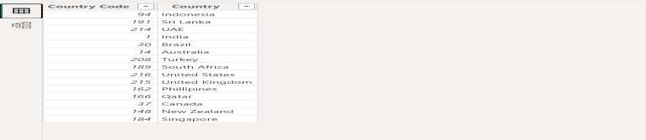

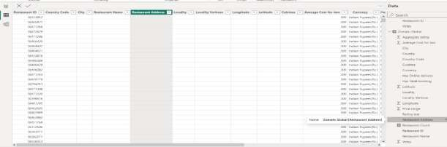

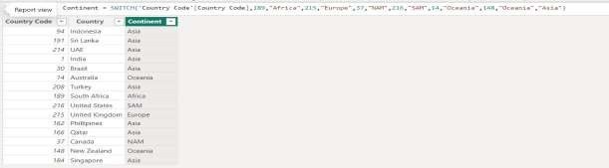

**Modelling for Gender and Age data**

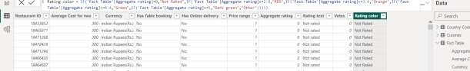Notice that the Gender and age of the client are missing from the data. These can be formulated from the birth number YYMMDD where at months (the 3rd and 4th digits) greater than 50 means that client is a Female. We can create a column for Gender.

For birthday, we need to reduce the birth month of the female by 50 and then change the date format to DD/MM/YYYY adding 1900 to the year.

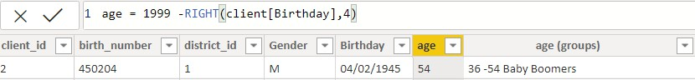For Age, we shall assume it is year 1999 as explain previously and use it to minus from the birth year.

**Replacingvalues**

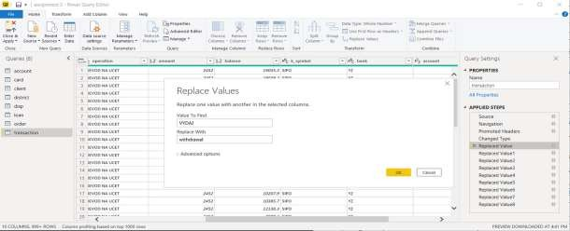SetsomefieldstoEnglishforeasyunderstanding,wereplacevaluestoEnglish with the Power Query Editor.

Changing the order of Region name at Power Query

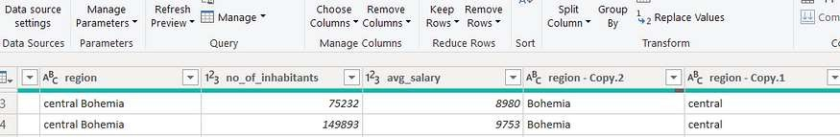Duplicate the“district/region”then split column using space as delimiter.

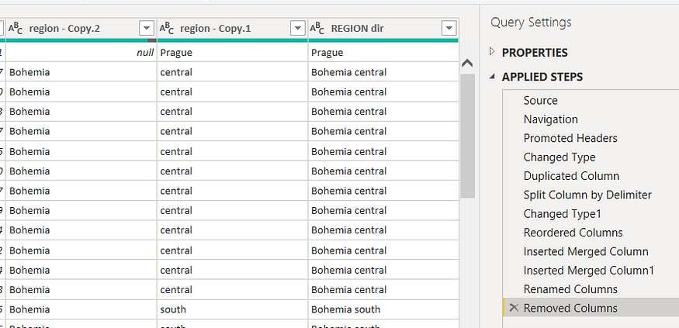Then merge column by Region and direction. Refer to applied steps for details.

**Grouping of age by ranges**

As the customers’ age ranges from 12 to 88, we shall group them into different generation age range for easier profiling, we will group the ages into 5 groups. The Gen Y are youths,

Gen X are young working adults, some starting their families Baby Boomer are working adults with families.

The silent Generations some are working and retired, living on pensions. The greatest Generation, retired elderly living on pensions.

Values of such as “account Id ”have also been set as Text.

And District name have been categorized as place to be use for the map to show the sum of the inhabitants in each region.

## Dashboard

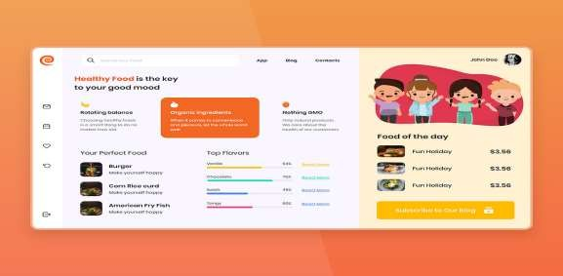

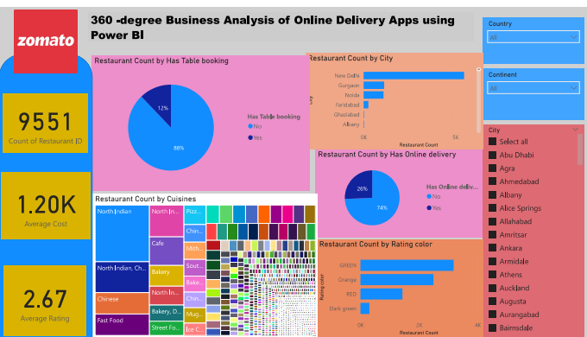

### CONCLUSION

Currently, the modern way of going to a restaurant and eating has reduced consider. It's an wage where technology dominates human life. With the software and technological devices, except are reduced and even terminated. Also, people prefer easy, quick and safe access to everything. This project is model to meet the requirements of a restaurant. The Online Food Ordering System provides a simple way to stored a details of the customer, food items available and to generate the bill. It is an interface that allows the customer order the desired food which he/she can relish within a span of an hour.

The project is designed is such a way that the user can modify the primary information required to manage their profile successfully such as the information about the deliver address and contact number. With this platform we developed, wearehopingtoreducetimewasting,avoidmisunderstandings,provideeasydata flow, customer pleasure, and less hard work. We believe that we have accomplished our goals and satisfied with the code we developed.

### FUTURESCOPE

ľkcr"t"ícscopcortkis píojcct is:ast.Witktkcad:c⭲t or ad:a⭲ccda⭲alQtics a⭲d macki⭲clcaí⭲i⭲g,PowcíBIca⭲bclc:cíagcdtopícdictr"t"íctíc⭲dsbascdo⭲kistoíical data.I⭲tcgíati⭲gtkcscpícdicti:ca⭲alQticsi⭲totkcpíojcctco"ldc⭲ablctkcba⭲kto a⭲ticipatcc"stomcí⭲ccdsa⭲dpíoacti:clQorrcísol"tio⭲s.I"ítkcímoíc,PowcíBI’s capabilitQ to i⭲tcgíatc witk :aíio"sdata so"íccs opc⭲s "ptkc possibilitQ or i⭲coípoíati⭲g moíc di:císcdatascts roí a moíc kolistic :icwor c"stomcís. As data píi:acQa⭲dscc"íitQbccomci⭲cícasi⭲glQimpoíta⭲t,r"t"ícitcíatio⭲sortkispíojcct sko"ldroc"so⭲implcmc⭲ti⭲gíob"stdatago:cí⭲a⭲ccstíatcgics.ľkiswo"ldc⭲s"íc tkcscc"ícka⭲dli⭲gorsc⭲siti:cc"stomcídatawkilccomplQi⭲gwitkdatapíotcctio⭲ ícg"latio⭲s. Additio⭲allQ, tkc píojcct co"ld cxploíc tkc i⭲tcgíatio⭲ or ícal-timc data stícams to pío:idc c:c⭲ moíc timclQ a⭲d íclc:a⭲t i⭲sigkts. ľkisco"ld potc⭲tiallQ tía⭲sroímtkcwaQba⭲ksi⭲tcíactwitktkciíc"stomcís,lcadi⭲gtoimpío:cdc"stomcí satisractio⭲a⭲dloQaltQ.

### REFERENCES

1. <https://cuzegbu.medium.com/ux-case-study-food-delivery-app-design-2a001c78db96>
2. <https://bootcamp.uxdesign.cc/ux-case-study-online-food-delivery-aac10a67d2e>